INDICATIVE APPLICATION FORM A
DISRUPTIVE TECHNOLOGIES INNOVATION FUND - CALL 8
* Question is required for completion of application.
Registration Details
First Name

Last Name

Email Address

Pre-eligibility Check
1* The consortium must engage with the DTIF team to complete the pre-eligibility screening prior to submitting an application. Please upload evidence confirming that a pre-eligibility meeting with the DTIF team has taken place. Acceptable evidence includes a screenshot or PDF copy of an email from the DTIF team confirming that the pre-eligibility meeting has taken place.
(Not applicable for paper form.)

Please email DTIF@enterprise-ireland.com to contact the DTIF team.

 | Confirmation of Client Status
2* | Please upload proof of agency status with Enterprise Ireland, IDA Ireland or Údarás na Gaeltachta for each enterprise partner in the consortium. The Lead Applicant must collect and submit this evidence on behalf of all enterprise partners.  Screenshots or PDFs of confirmation emails from the relevant Client Advisor are acceptable.  (Not applicable for paper form.)

 | Proposal Details
3* | For technical support contact support@submit.com  Proposal Title

4* | Acronym
5* | Project Mission/Goal  (Max 50 words)

List of Participants

Please identify all industry partners under the appropriate cost model section (choosing either the SIMPLIFIED OVERHEAD model or the DEFINED OVERHEAD model). Separate sections are provided for SMEs and Large Enterprises. Each industry partner must be assigned to one cost model only. RPO participants and non-funded partners should be listed separately in the respective sections at the end.

6 | List of SME Participants OPTION 1: SIMPLIFIED OVERHEAD  If availing of OPTION 1 please complete Table 1.  For more information on OPTION 1 SIMPLIFIED OVERHEAD please refer to Guide for Applicants.
Participant No
Organisation Name
Is a company? (Yes/No)
Client of Agency
Agency Client Ref. Number
ES1
ES2
ES3
ES4
ES5
7 | List of SME Participants OPTION 2: DEFINED OVERHEAD  If availing of OPTION 2 please complete Table 2.  For more information on OPTION 2 DEFINED OVERHEAD please refer to Guide for Applicants.
Participant No
Organisation Name
Is a company? (Yes/No)
Client of Agency
Agency Client Ref. Number
ED1
ED2
ED3
ED4
ED5
8 | List of LARGE Enterprise Participants OPTION 1: SIMPLIFIED OVERHEAD  If availing of OPTION 1 please complete Table 3.  For more information on OPTION 1 SIMPLIFIED OVERHEAD please refer to Guide for Applicants.
Participant No
Organisation Name
Is a company? (Yes/No)
Client of Agency
Agency Client Ref. Number
ELS1
ELS2
ELS3
ELS4
ELS5
9 | List of LARGE Enterprise Participants – OPTION 2: DEFINED OVERHEAD  If availing of OPTION 2 please complete Table 4.  For more information on OPTION 2 DEFINED OVERHEAD please refer to Guide for Applicants.
Participant No
Organisation Name
Is a company? (Yes/No)
Client of Agency
Agency Client Ref. Number
ELD1
ELD2
ELD3
ELD4
ELD5
10 | List of RPO Participants  Please only enter RPO Participants in the table below.
Participant No
RPO Name
If "other"
please specify RPO Name
R1
R2
R3
R4
R5
11 | List of NON-FUNDED Participants  Please only enter NON-FUNDED Participants in the table below.
Participant No
Organisation Name
If "other"
please specify the Name of the non-funded partner
NF1
NF2
NF3
 | Contact Details
12 | Please fill out the contact details for all project partners, including non-funded partners:
Participant
Organisation Name
Type of Organisation
Is a company? (Yes/No)
Email Address
Mobile Phone Number
Lead Applicant
Consortium Partner
Consortium Partner
Consortium Partner
Consortium Partner
Consortium Partner
Consortium Partner
Consortium Partner
Consortium Partner
Consortium Partner

 | Research Priority Area
13* | Please select your Research Priority Area from the dropdown  (Circle your selected answer)
a)
ICT
b)
Health and Wellbeing
c)
Food
d)
Energy, Climate Action and Sustainability
e)
Manufacturing and Materials
f)
Innovation in Services and Business Process
 | Executive Summary
14* | Executive Summary  (Max 600 words)

 | Project Details, Criterion and Work Packages
15* | Please upload Part B of the DTIF Call 8 application form containing;  General Project Information  Selection Criterion 1, 2, 3 and 4  Work Packages  Signatures  Information About the Consortium  Tables 1-6  Please note that only applicants that are listed in Part A should complete and be included in Part B of the application form.  Please click here to download the DTIF Call 8 template for Part B.  (Not applicable for paper form.)

 | Breakdown of Costs
16 | Breakdown of costs per SME partner OPTION 1 SIMPLIFIED OVERHEAD:  Note: Please only enter costs for SME participants in the table below.  Please refer to Guide for Applicants for more information  Budget information should be provided in TABLES 13, 14, 15, 16 & 17. Note that no further budget information should be included in PART B of the application.
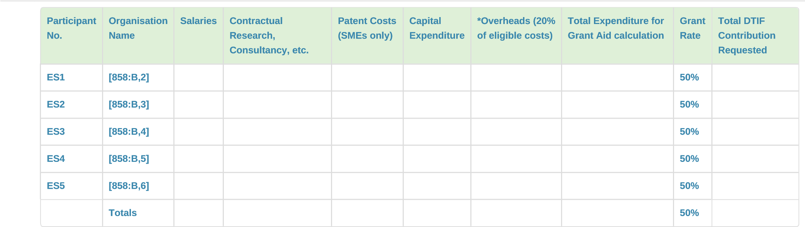
17 | Breakdown of costs per SME partner OPTION 2 DEFINED OVERHEAD:  Note: please only enter costs for SME participants in the table below.  Please refer to Guide for Applicants for more information  Budget information should be provided in TABLES 13, 14, 15, 16 & 17. Note that no further budget information should be included in PART B of the application.
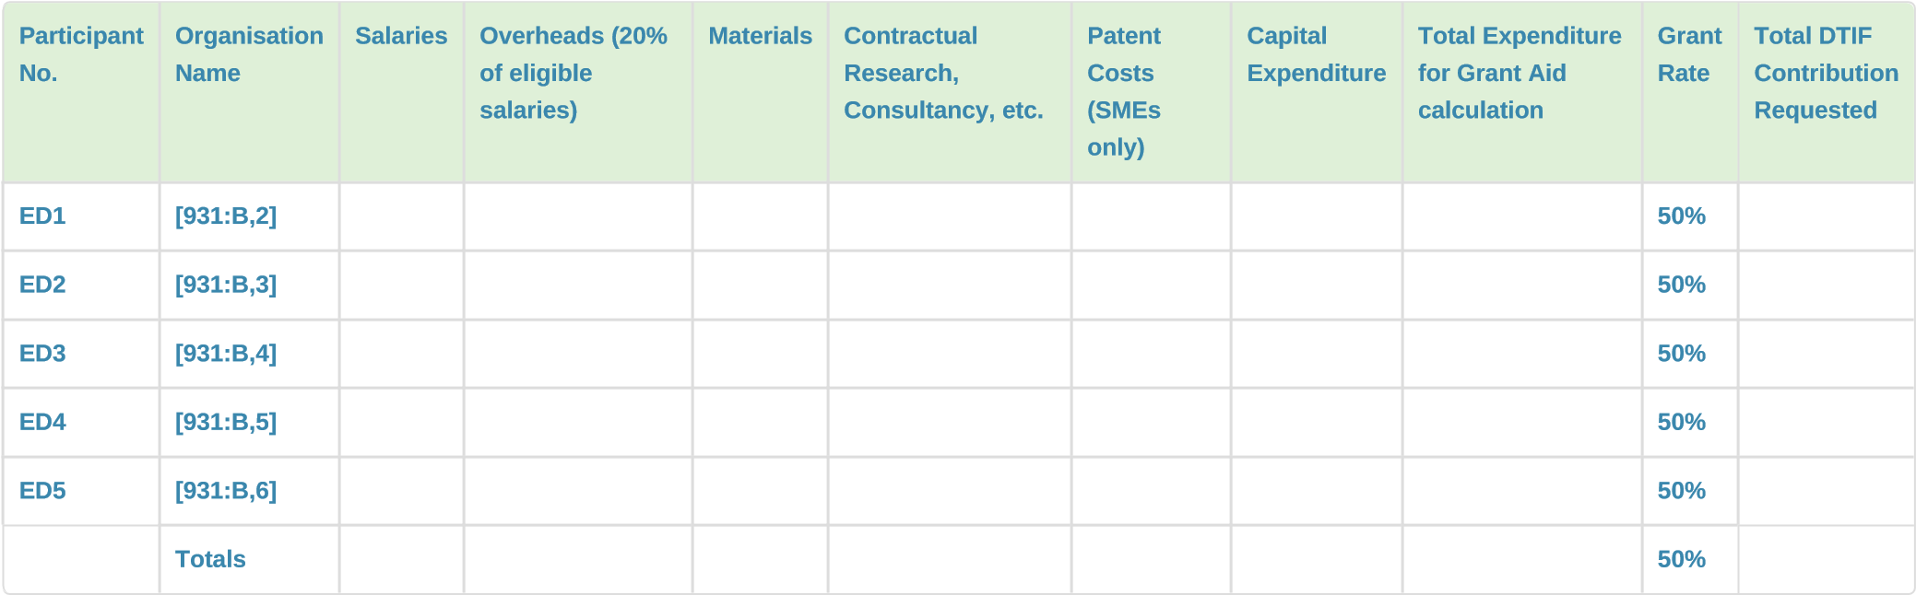
18 | Breakdown of costs per LARGE partner OPTION 1 SIMPLIFIED OVERHEAD:  Note: Please only enter costs for LARGE participants in the table below.  Please refer to Guide for Applicants for more information  Budget information should be provided in TABLES 13, 14, 15, 16 & 17. Note that no further budget information should be included in PART B of the application.
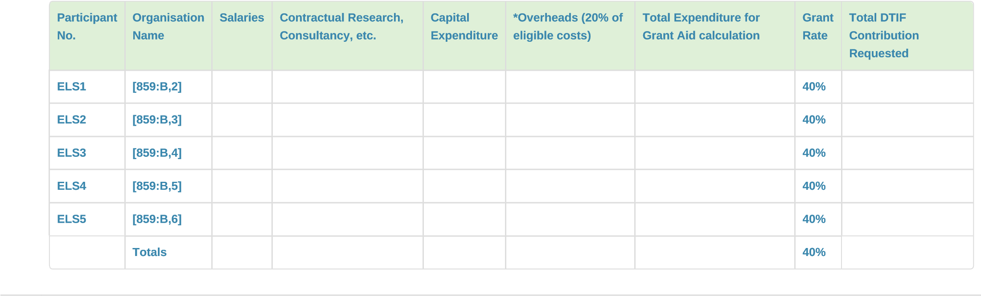

19 | Breakdown of costs per LARGE enterprise partner OPTION 2 DEFINED OVERHEAD:  Note: please only enter costs for LARGE enterprise participants in the table below.  Please refer to Guide for Applicants for more information  Budget information should be provided in TABLES 13, 14, 15, 16 & 17. Note that no further budget information should be included in PART B of the application.
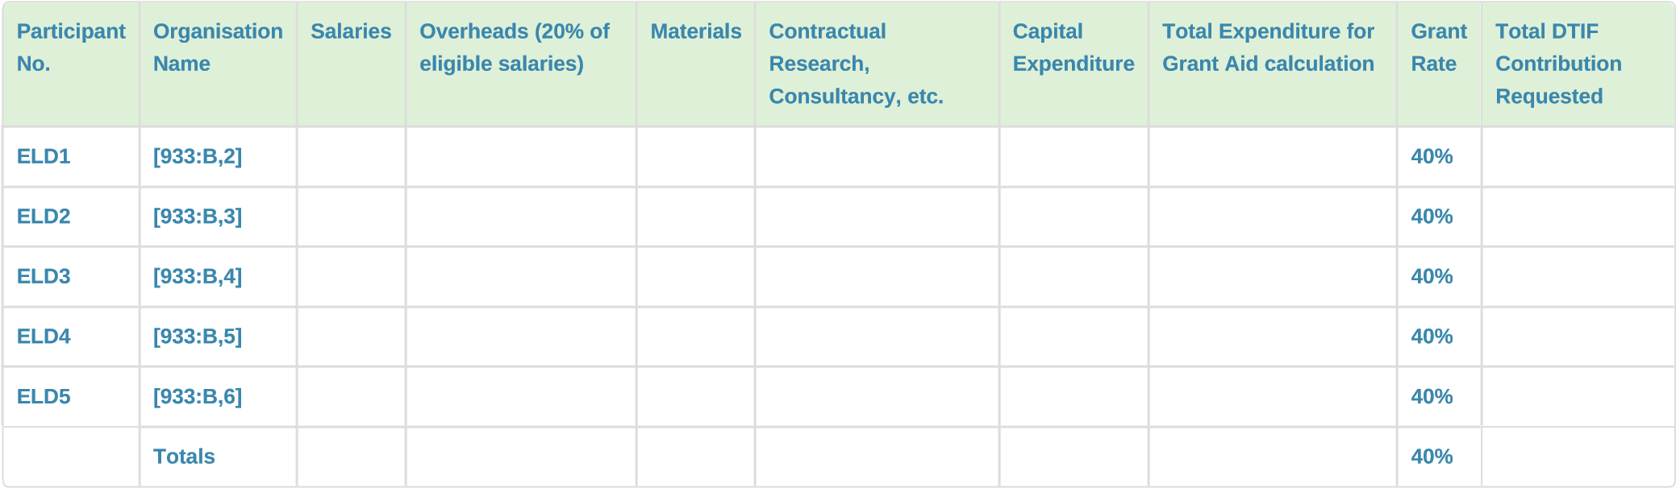
20  ​ | Breakdown of costs per RPO partner:  Note: please only enter costs for RPO participants in the table below.  Please refer to Guide for Applicants for more information  Budget information should be provided in TABLES 13, 14, 15, 16 & 17. Note that no further budget information should be included in PART B of the application.
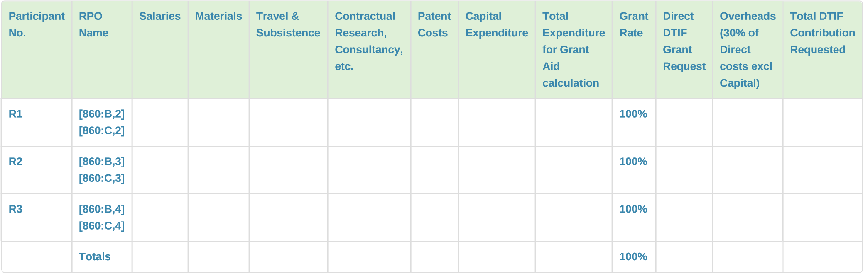
 |  | Proposed Budget
21 | Project Budget - Overall budget for the proposal (per partner)  Please indicate the Lead Partner (column 3)
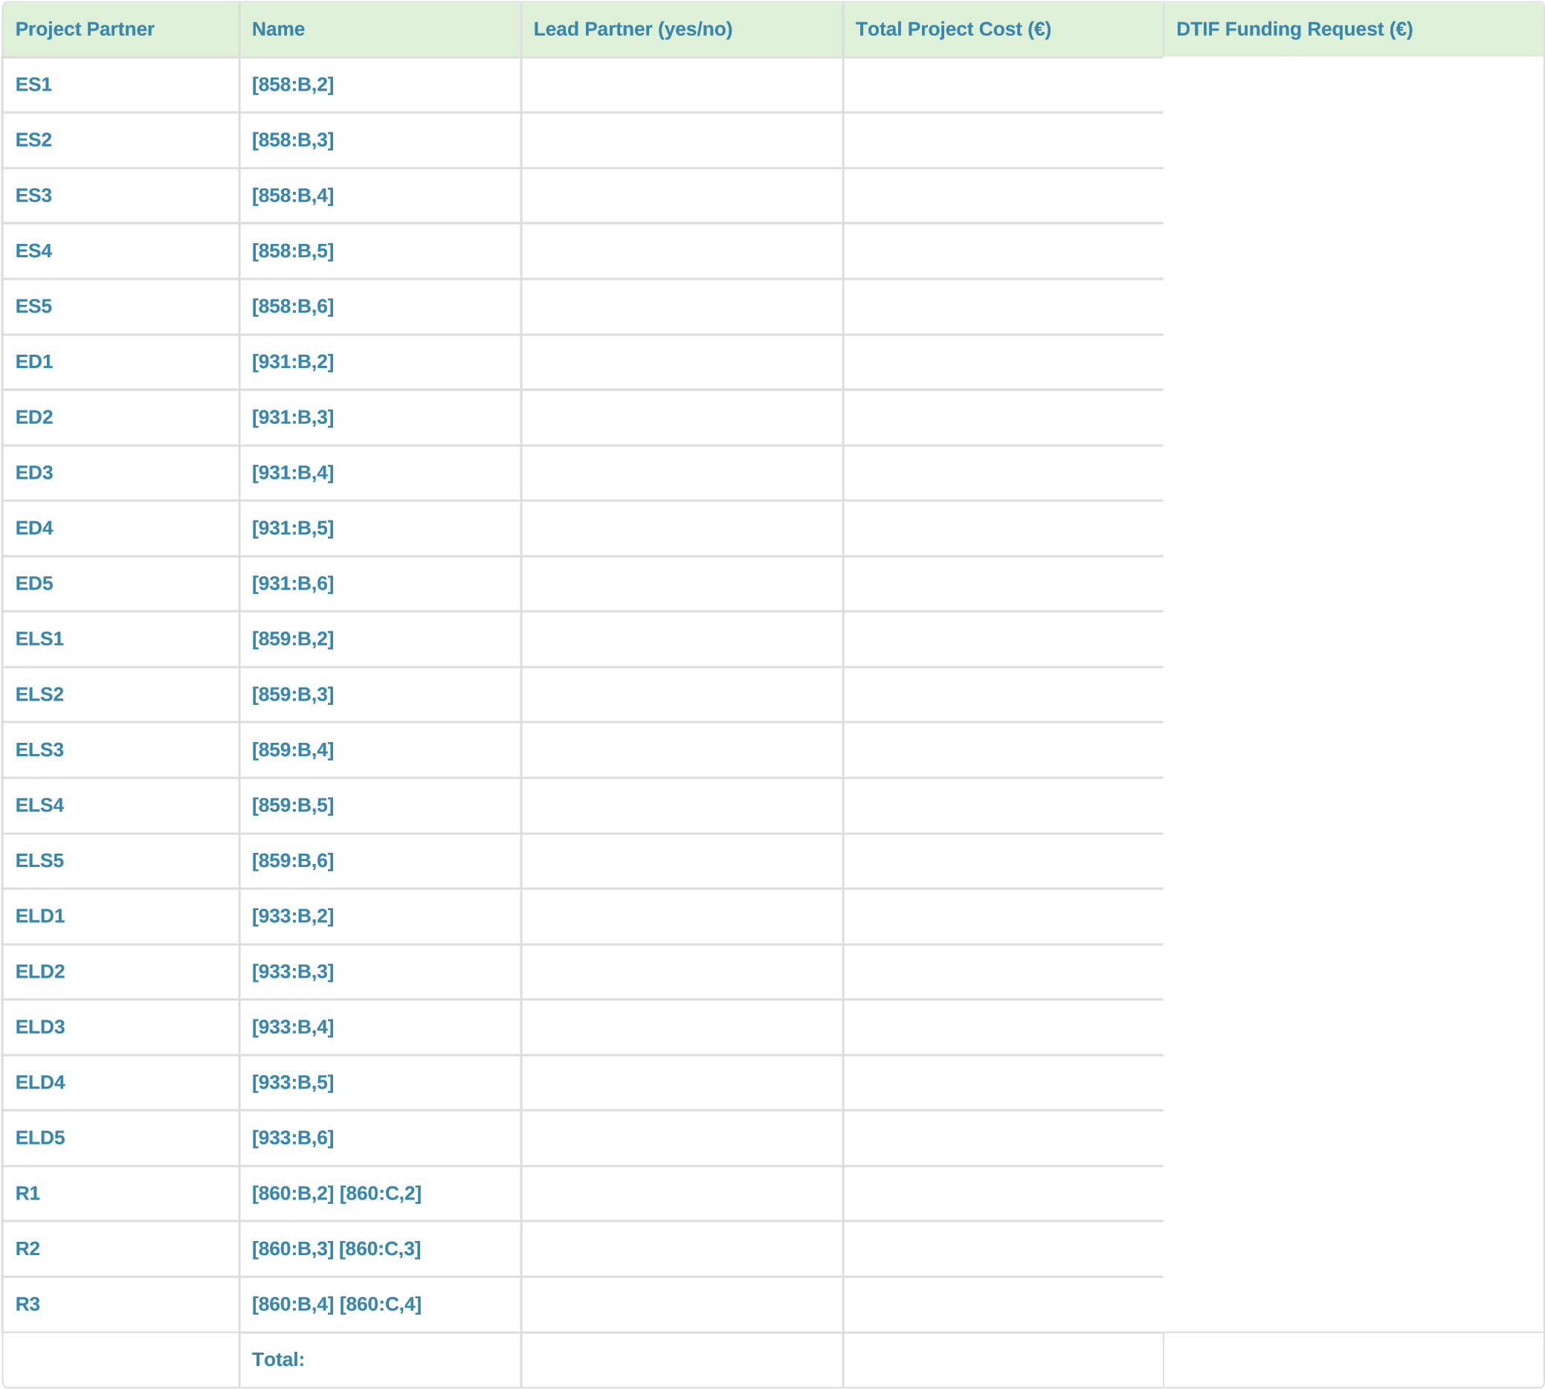
22* | Proposed Budget  The consortium must be requesting a minimum funding from DTIF of at least €1.5 million over 3 years  RPOs cannot receive more than 50% of the total DTIF grant aid to the project in any collaboration  Failure to comply with the above criteria will result in the application being ineligible for funding
Total Project Cost (€)
DTIF Grant Requested (€)
DTIF Grant Request (%)
RPO %
Financial Documentation
23* Please confirm that the financial documentation for all enterprise partners participating in this application has been submitted by email to DTIFFinance@enterprise-ireland.com.
(Circle all that apply)

By ticking the box below, the lead partner confirms that all required financial documentation has been submitted and that the information provided is complete, accurate and consistent with the details contained elsewhere in the application.
Please click here to download the DTIF Call 8 UiD questionnaire.
a) I confirm that all required financial documentation for the enterprise partners participating in this application has been submitted to DTIFFinance@enterprise-ireland.com and
that the information provided is complete, accurate and consistent with the deta

Use of AI tools
24* Please describe any use of AI tools used in the preparation of this application, including details of the extent and purpose of such use.
(Max 300 words)

Applicants remain responsible for the accuracy, completeness and originality of all information submitted and should ensure that any use of AI complies with the DTIF Guide for Applicants.
For further information see the Living guidelines on the responsible use of generative AI in research.

 | Declarations
25* | The lead partner declares to have the explicit consent of all applicants on their participation and on the content of this proposal.  (Circle all that apply)
a) I confirm the above

26* | The lead partner declares that each applicant has confirmed  - eligibility in accordance with the criteria set out in the specific call for proposals ('Eligibility Criteria' section of the Guide for Applicants.  - financial and operational capacity to carry out the proposed action.(Circle all that apply)
a) I confirm the above

27* | The lead partner hereby declares that each enterprise applicant has confirmed that it is not an Undertaking in Difficulty (as defined in the 'Declaration of Non-Undertaking in Difficulty' section of the Guide for the Applicants).  (Circle all that apply)
a) I confirm the above

28* | The lead partner declares responsibility for the correctness of the information relating to his/her own organisation. Each applicant remains responsible for the correctness of the information related to him/her and declared above. Where the proposal is approved for DTIF funding, the lead partner and each beneficiary partner will be required to present a formal declaration in this respect.  (Circle all that apply)
a) I confirm the above

29* | The lead partner declares that this proposal has not been approved for funding under other NDP Funds (Urban, Rural, Climate Action)  (Circle all that apply)
a) | I confirm the above

30* | The lead partner declares that this project has not received any other grant aid – either from Irish agencies or EU funds.  (Circle all that apply)
a) | I confirm the above
31* | The lead partner declares that this project will not involve activities or results raising security issues or 'EU-classified information' as background or results  (Circle all that apply)
a) I confirm the above

32* | Restrictive Measures in Force:  The Company represents and warrants that it is not directly or indirectly, or the Promoter represents and warrants that the Company will not be directly or indirectly, by way of funding or shareholding, covered by Articles 1 and 2 of the European Council decision, (2014/145/CFSP) of 17 March 2014, and subsequent Regulations (960/2014, 1290/2014 and 833/2014) concerning restrictive measures in respect of actions undermining or threatening the territorial integrity, sovereignty and independence of Ukraine.  Further information available here  (Circle all that apply)
a) I confirm the above

33* | Processing of Data, including Personal Data is in compliance with the General Data Protection Regulation (the “GDPR”) and Data Protection Acts 1988 to 2018.  Information, including your Personal Data provided in this DTIF Funding Application will be processed by Enterprise Ireland, IDA Ireland, Science  Foundation Ireland, Údarás na Gaeltachta, the Department of Enterprise Trade and Employment (the “DETE”) and a Review Panel of International Experts for the purposes of evaluating applications and selecting a ranked list of Projects for funding.  We, Enterprise Ireland, IDA Ireland, Science Foundation Ireland, Údarás na Gaeltachta and the Department of Enterprise, Trade and Employment would also like to contact you from time to time to provide you with information and updates in relation to new projects or other funding supports that may be of interest.  I understand that my Personal Data will be processed by the above bodies, including Enterprise Ireland, IDA Ireland, Science Foundation Ireland, Údarás na Gaeltachta and the Department of Enterprise, Trade and Employment. This processing will be conducted in accordance with the various Privacy Policies of these bodies.  We request that you read the above notification carefully and that you ensure that it is made available to any data subjects (e.g. your employees) whose personal data you provide to us.  By giving your consent, you confirm that:  - you have complied with your own data protection obligations in respect of the personal data that you supply to us and that you are entitled to disclosesuch personal data to us; and  - you will ensure that the above is sent to data subjects (e.g. your employees) whose personal data you provide to us.  I consent to the above bodies processing my Personal Data to contact me in the future to provide me with information about projects or initiatives or funding supports. I understand that I can Opt-Out from receiving these communications by e-mailing: [dtif@enterprise-ireland.com].  (Circle all that apply)
a) I confirm the above

 | Confirmation
34* | I confirm that I, [user:fullname] and my organisation [q:3b6d49]:  - consent to participation  and  - that all partners have provided me with written confirmation of their consent to participate in this project for DTIF Call 8.

35* | The lead partner declares that each applicant has confirmed  - eligibility in accordance with the criteria set out in the specific call for proposals; and  - financial and operational capacity to carry out the proposed action.(Circle all that apply)
a) I confirm the above

